**EXP 3:** Create a simple cloud software application for Car Booking Reservation System using any Cloud Service Provider to demonstrate SaaS include the necessary fields such as search for cabs, from, to, rental, out station, Package type, hours/Days etc.,

**PROCEDURE:**

**STEP 1:** GO TO THE ZOHO.COM

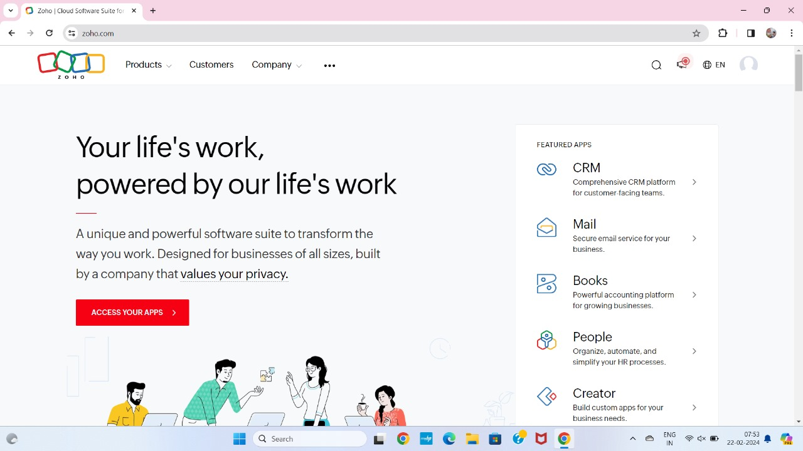

**STEP 2:** LOGIN TO THE ZOHO.COM

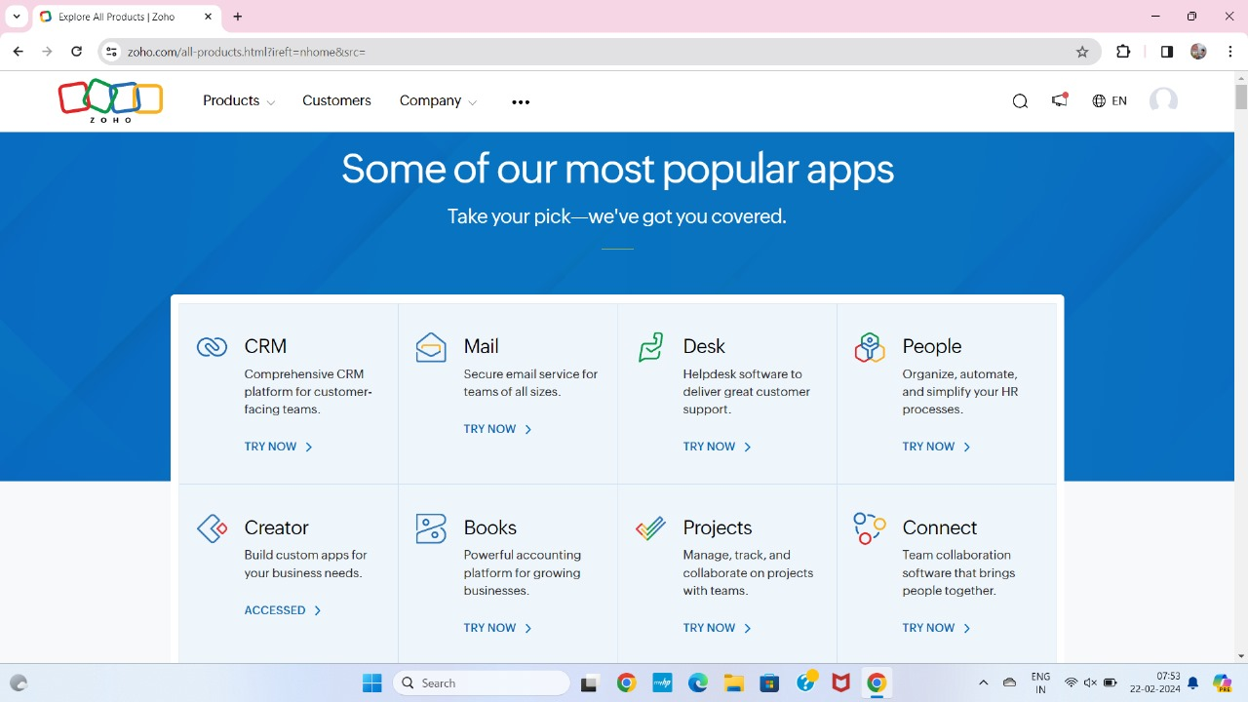

**STEP 3:** SELECT THE CREATE FROM SCRATCH

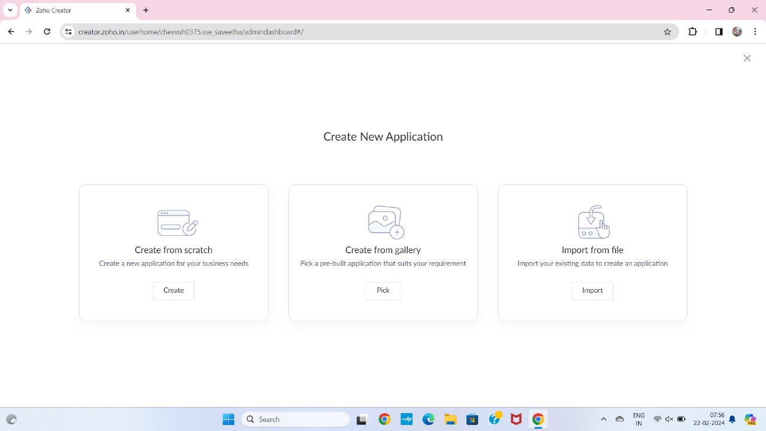

**STEP 4:** SELECT APPLICATION NAME AS CAR BOOKING RESERVATION SYSTEM

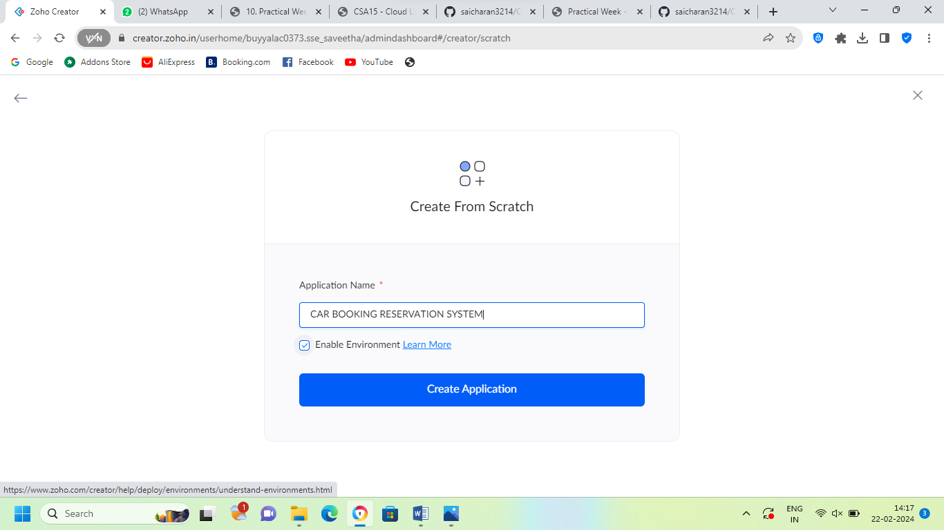

**STEP 5:** CREATE A NEW FORM

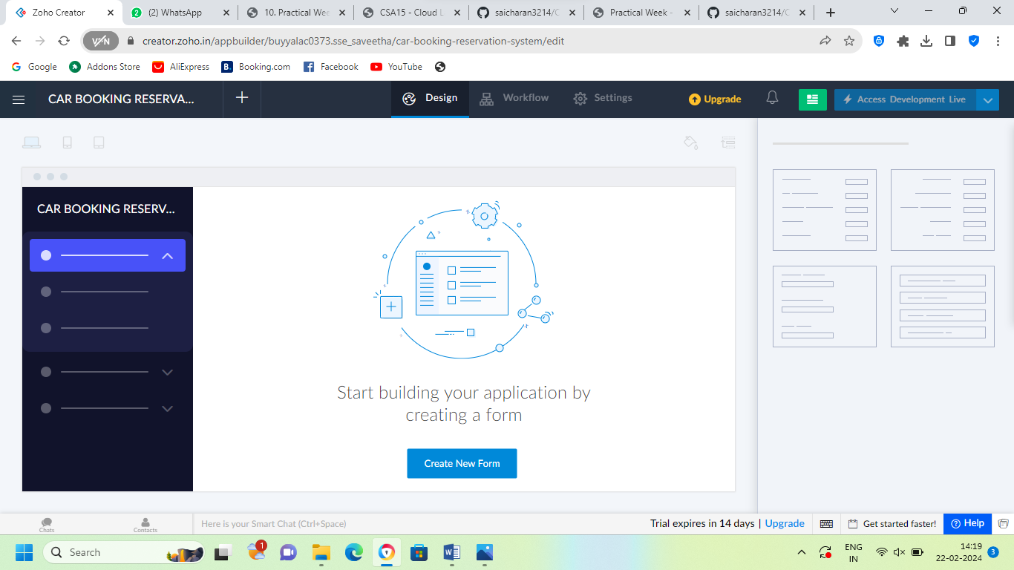

**STEP 6:** SELECT BASIC FIELD FROM GIVEN BELOW AND DEVELOP APPLICATION

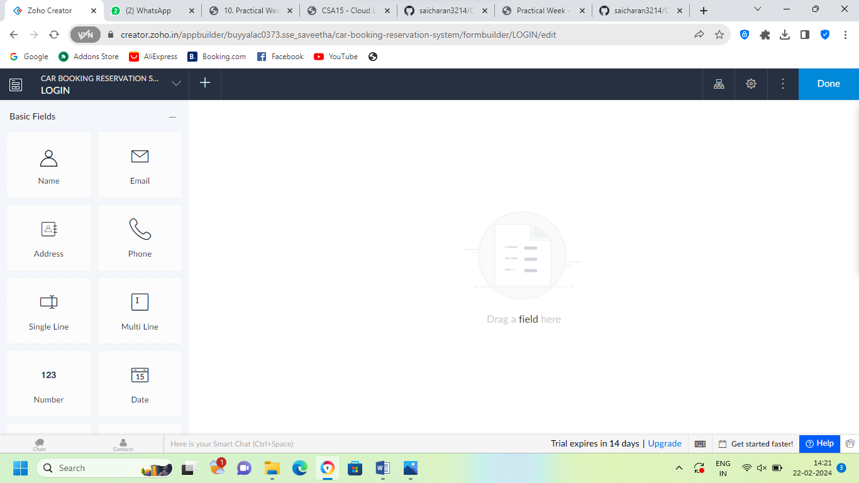

**STEP 7:** THE SOFTWARE HAS BEEN CREATED LOGIN PAGE

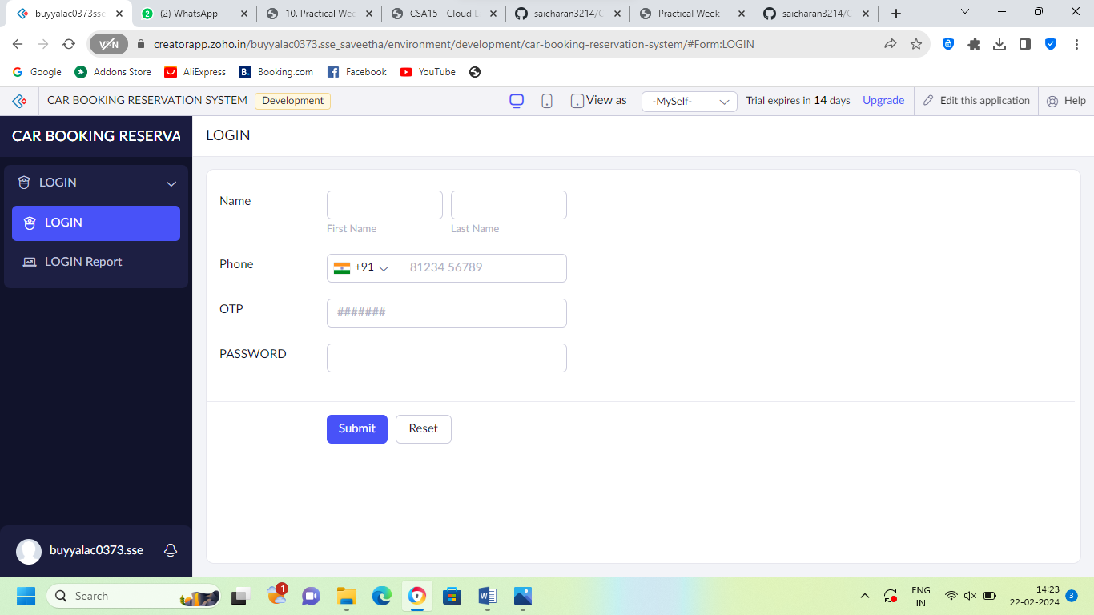

**STEP 8:** THE SOFTWARE HAS BEEN CREATED HOME PAGE

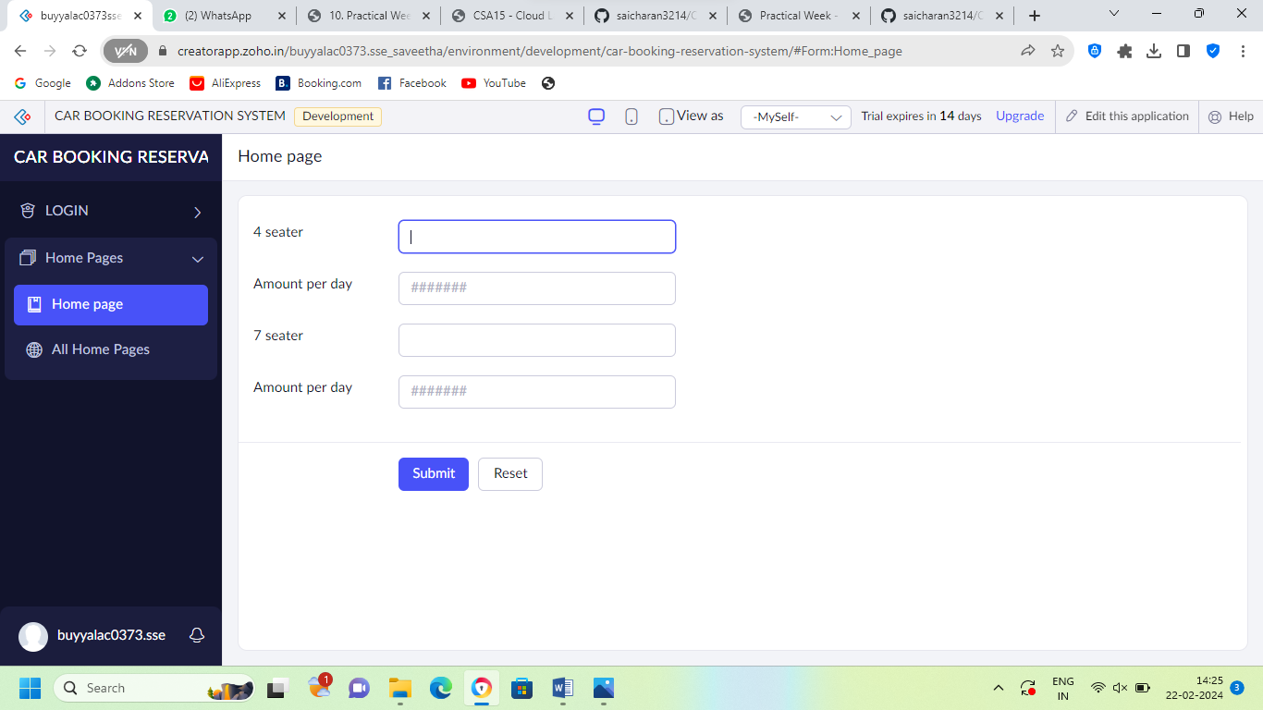

**STEP 9:** THE SOFTWARE HAS BEEN CREATED USER

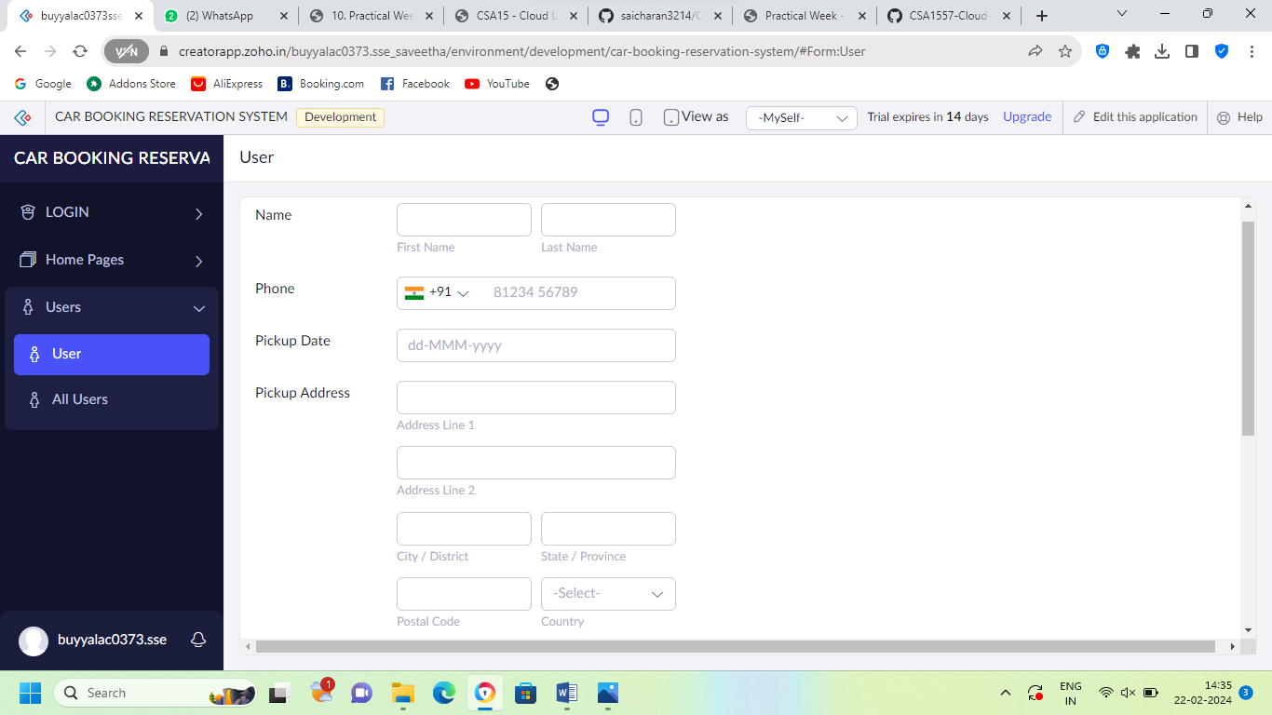

**STEP 10:** THE SOFTWARE HAS BEEN CREATED PAYMENT

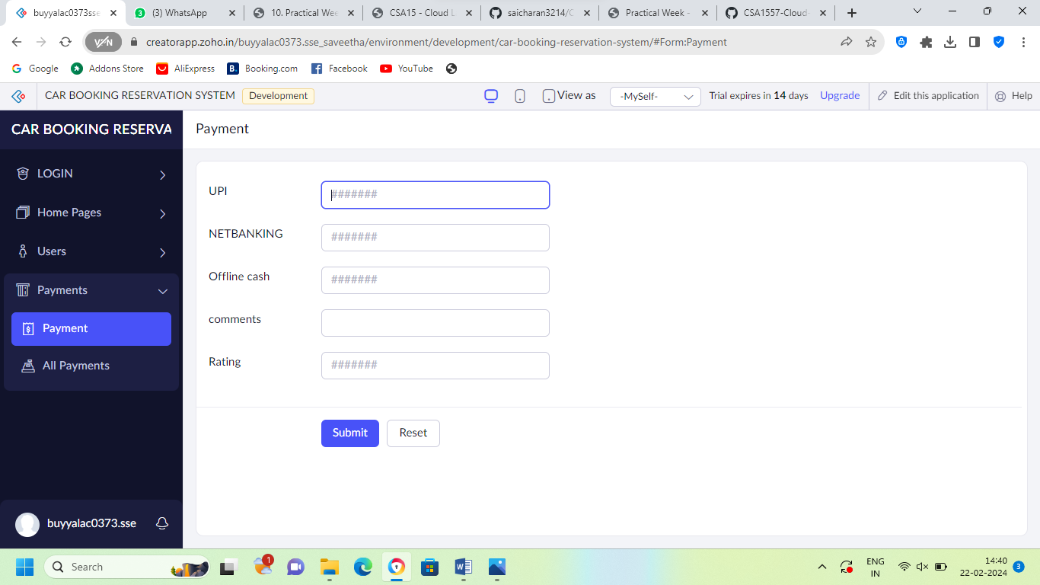

**STEP 11:** FINALLY THE SOFTWARE HAS BEEN CRAETED

